User Guide

Administrator

1. Main Panel

Form the main panel the user (Administrator) need to click the dispatch icon as listed on the image below.

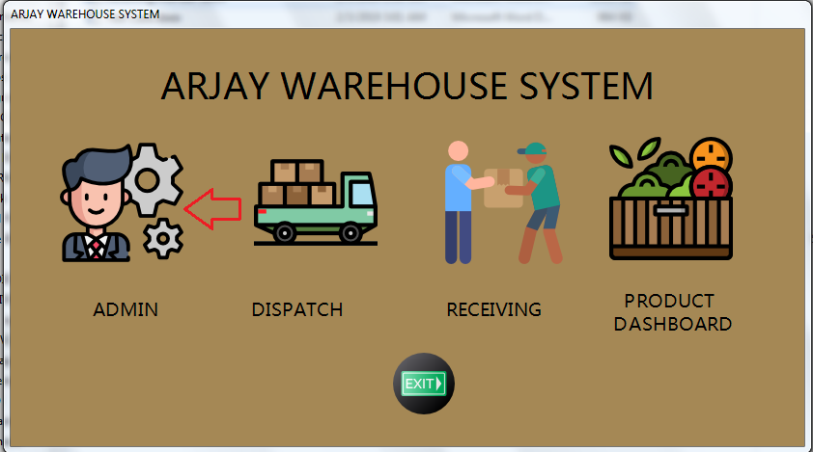

1. Login

After clicking the dispatch icon the dispatch personnel is required to enter the credential given to him/her by co - system administrator.

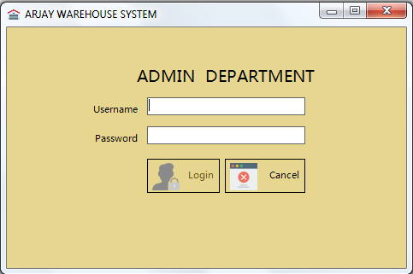

Here is the error message if credential entered is incorrect.

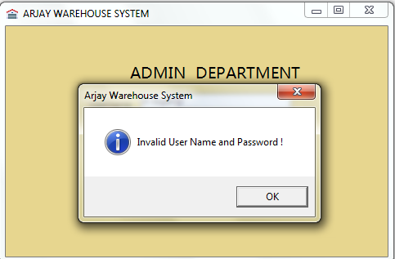

1. Admin Dashboard

After a successful login the Administrator will be redirected to the Admin Dashboard Pane. Here the Administrator can see various option that he can use for production reason.

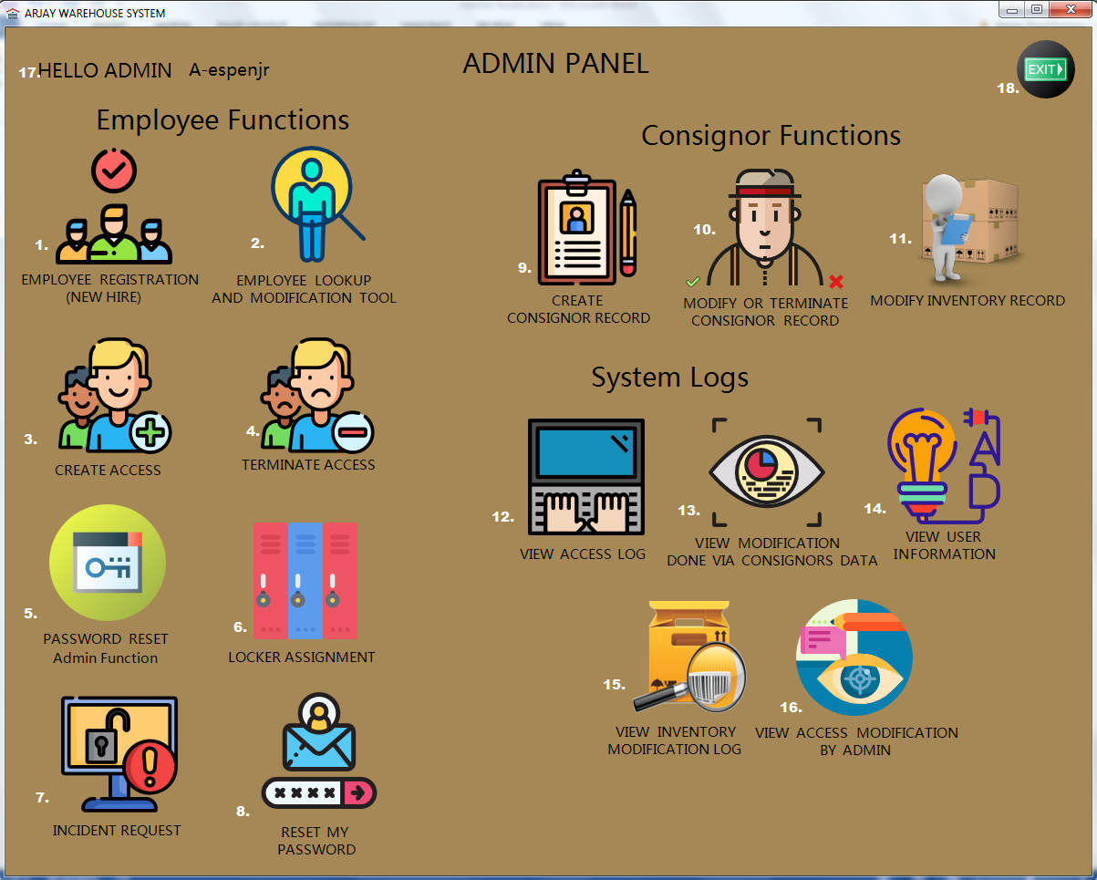

Here are the list of the functions available:

1. Employee Registration – Used to register a new or existing employee (for access purposes).
2. Employee Lookup – This function is being used to search for an employee record, update or even delete employee’s profile.
3. Create Access – Use to create an access to this system (applicable for Admin, Dispatch and Receiving).
4. Terminate Access – Function needed to terminate an access (applicable for Admin, Dispatch and Receiving).
5. Password Reset Admin Function - Function needed to manually reset employee’s password (applicable for Admin, Dispatch and Receiving).
6. Locker Assignment – Use this feature to assign a locker to certain employees.
7. Incident Request – Feature needed to view, modify and resolved incident or correction request.
8. Reset my password – Self-help feature to reset Administrators own password.
9. Create Consignors Record – Used to create consignors profile or data.
10. Modify or Terminate Consignors record – Feature needed to either update or terminate consignors’ record.
11. Modify Inventory Record – Use to modify inventory record submitted or requested by either receiving or dispatch department.
12. View Access Log – Feature to view all access made using this system (for both entry and exit).
13. View Modification done via Consignors data – This function can be used to track or identify the changes made onto a consignor’s data.
14. View Users Information – Use to view all the employees who do have access to “Arjay Warehouse System” (all applicable for all user type Admin, Dispatch and receiving).
15. View Inventory Modification Log – Form required to view system generated process done by an Administrator via client or consignors Inventory record.
16. View Access Modification by Admin – Feature needed to view changes and actions done by an Administrator (via employee level).
17. Greeting message and the user id of the person who is currently logged in.
18. Exit button - Can be used to terminate the session.

4.1. Employee Registration

1. Use this to register a new or existing employee, this is required in order for an administrator to create an access (applies for all three access role: admin, dispatch and receiving).

The administrator needs to click the button or icon as described below.

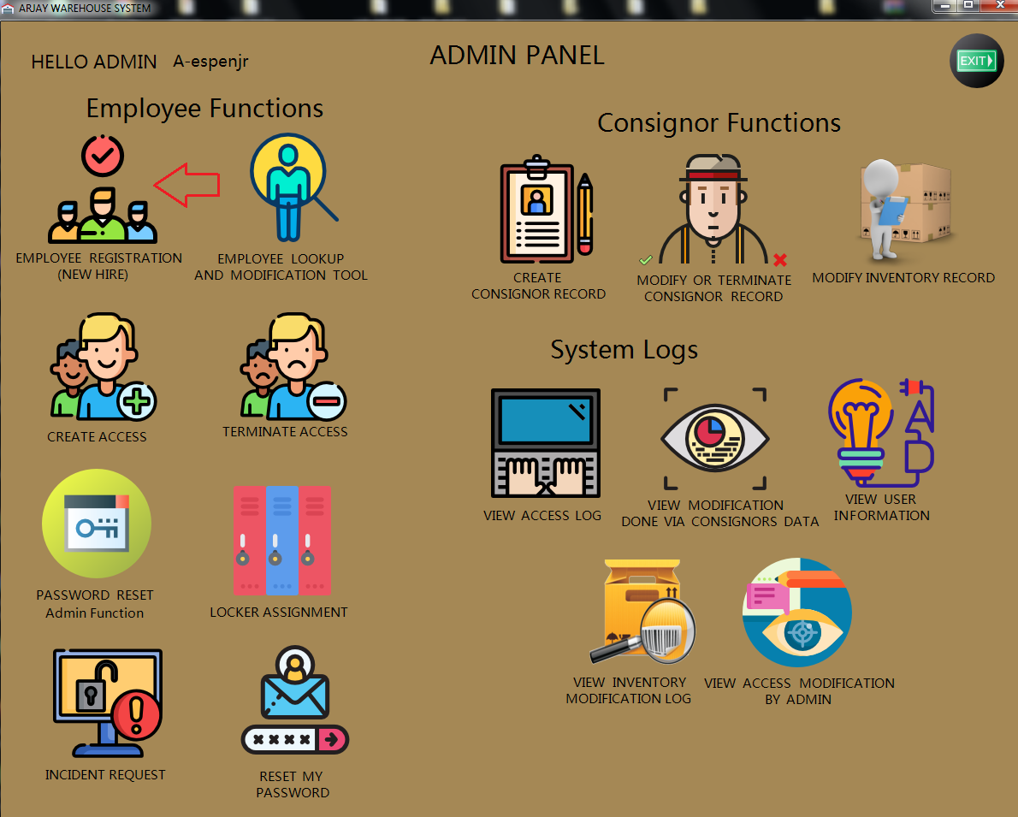

After clicking the Employee Registration button from the Admin Dashboard the employee registration form will appear.

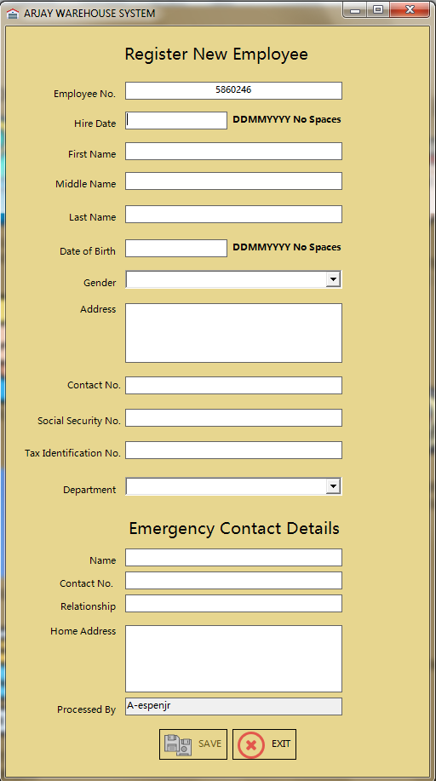

Note: Employee no. will be generated automatically when the main form or application loads and by default the save button will not go to an active state if there’s an empty field.

1. Once all the information are completely filled up, that is the only time that save button will be set to active state or clickable.

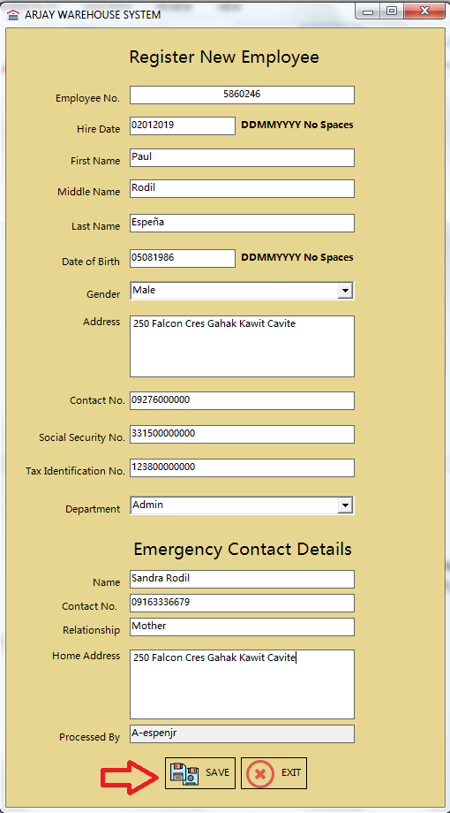

1. Successful message will be prompted once done.

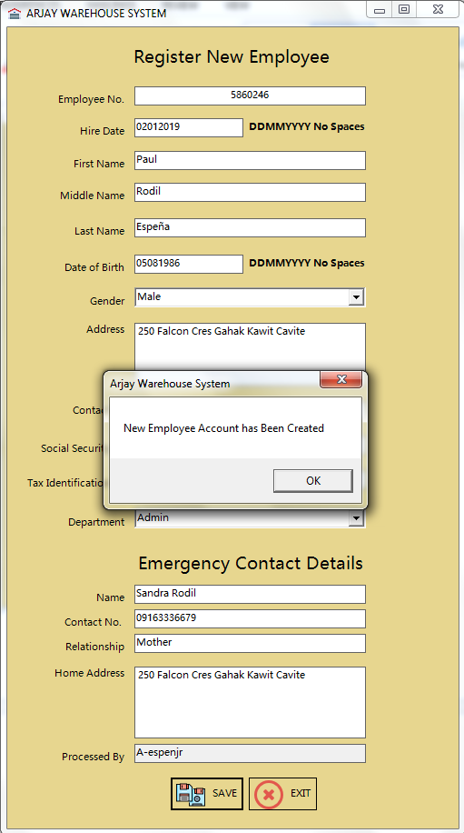

Note: After hitting the ok button system will going to clear all the fields listed in the form and Clicking exit button will close this form.

* 1. Employee Lookup

Use this to search, view, modify or update and delete employee’s information.

The administrator needs to click the button or icon as described below.

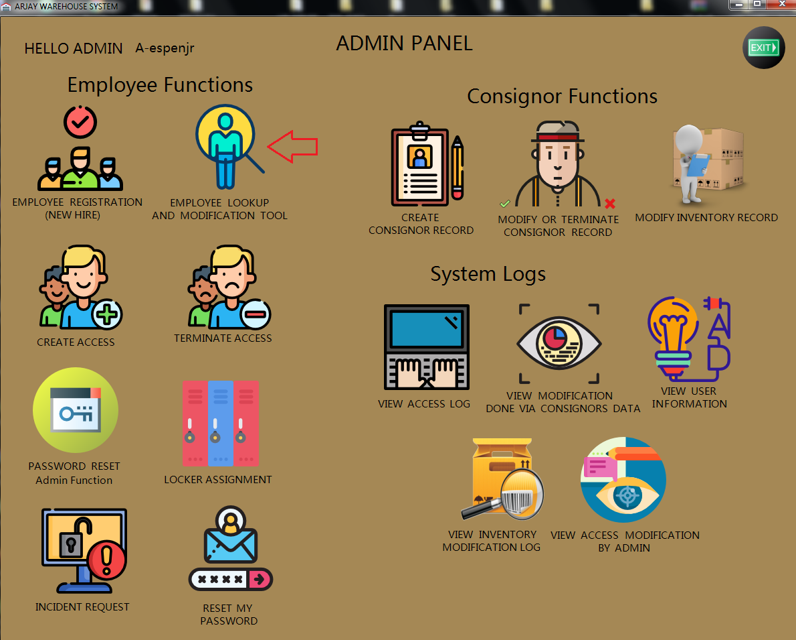

After clicking the Employee Lookup button from the Admin Dashboard the form will appear as described below.

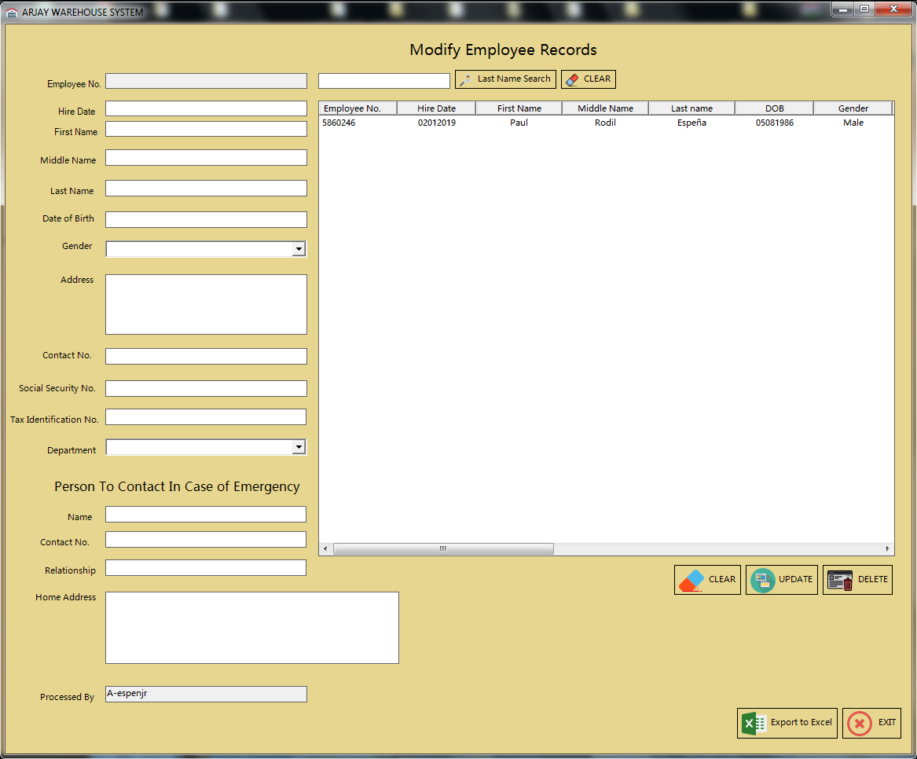

Note: Employee Lookup Form is being divided into multiple section and functions.

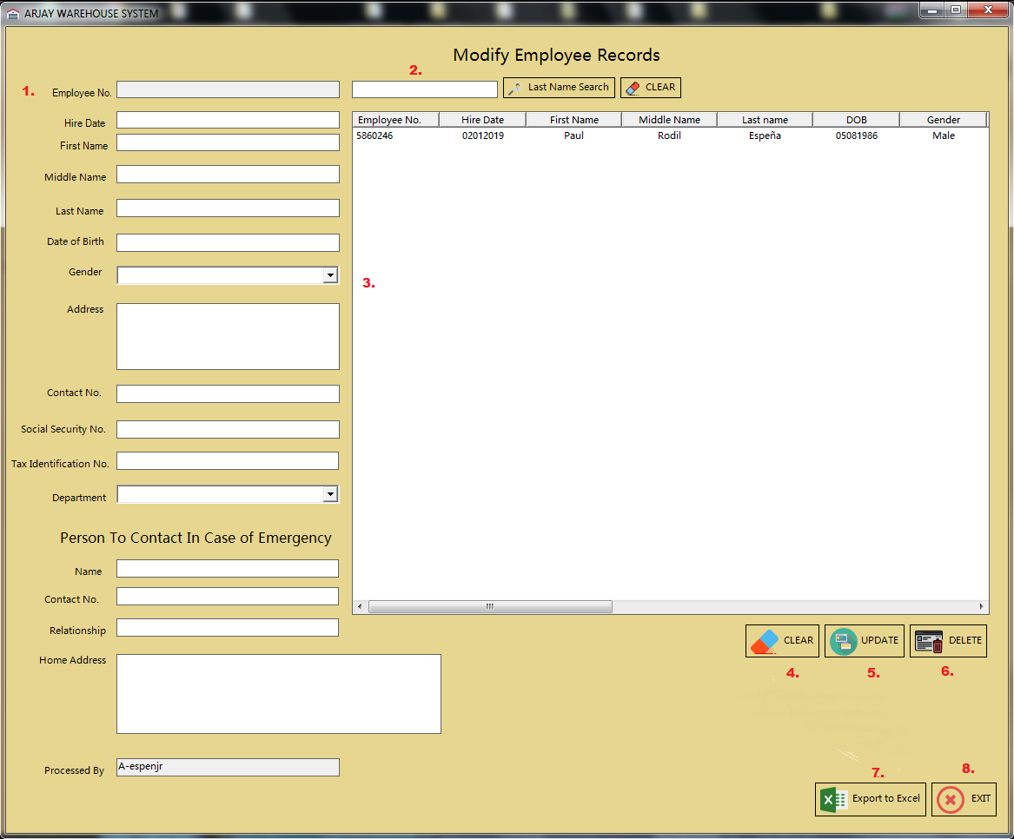

Here are the list of the sections associated with form:

1. Information panel – This is where the employee information will be displayed, this is applicable for edit and delete function.
2. Search function – Administrator can use this to search for an employee using the employee’s last name.
3. List view panel – This will display all the employee information that the administrator created (please see Employee Registration process).
4. Clear Button – This button will going to clear all the information present via Information panel.
5. Update Button - This button will save the changes made once the administrator made some changes to an employee’s data or profile.
6. Export button – This function will export all the data listed in the list view panel all the way to an excel spreadsheet (excel application is required).Using this function it will be easier for the administrator to filter the searches and can also be used for auditing and reporting purposes.
7. Exit button – Button used to exit or close this form.

Note: All changes that will be made using Employee lookup form will be log automatically. And administrators logon ID will be fetch for security and auditing purposes.

In order for the data to show up or to be listed onto the Information panel, the user or administrator need to click the data listed via list view panel or section. Once the data is placed or posted that is the best time to perform the necessary action required (as per description above).

Sample snapshot:

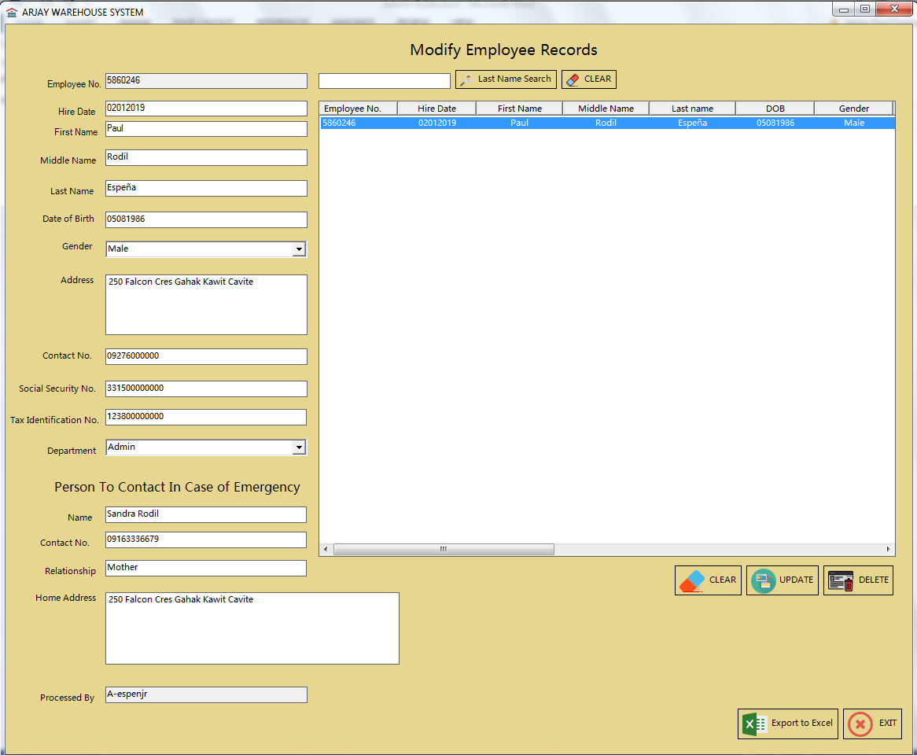

* 1. Create Access

Use this to create an access to this system “Arjay Warehouse System”. This procedure is applicable for all three access roles Admin, Dispatch and Receiving.

Reminder: To create an access please ensure that the employee is present to the employee’s database or record (Please see Employee Registration process).

The administrator needs to click the button or icon as described below.

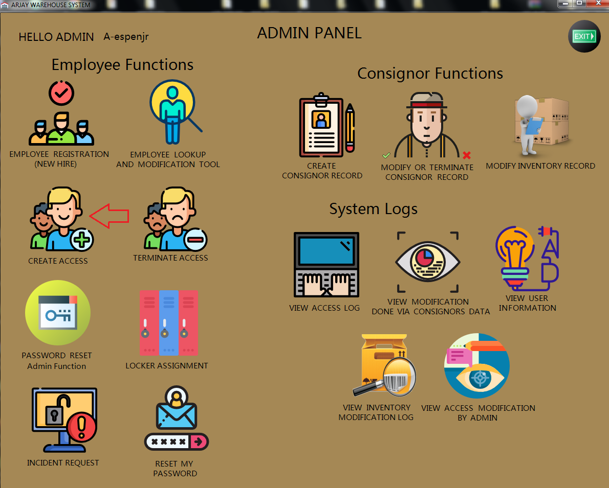

After clicking the Create Access button from the Admin Dashboard the create account panel will show up.

Snapshot of Create Account Panel:

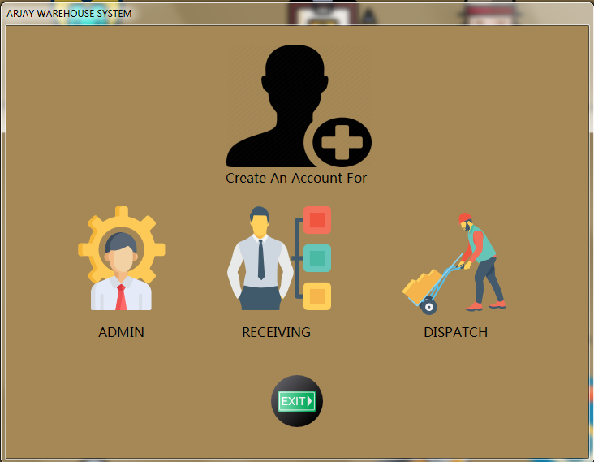

Administrator is required to choose the type of access that needs to be created.

Note: The procedure for all three roles are all the same as far as data and information are all concern.

After choosing or clicking the type of access needed the create access form will appear.

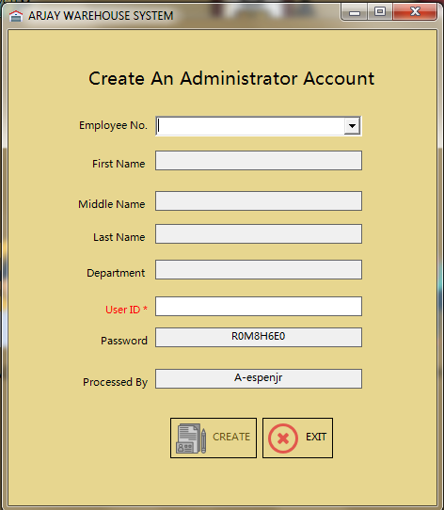

Administrator needs to click the drop-down arrow next to Employee No.

Reminder: The password is a system generated password and this form will generate it automatically and administrator cannot overwrite this field, manual reset is required if Administrator wanted to change this.

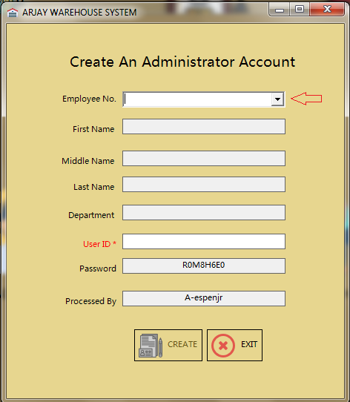

Snapshot after choosing the employees Employee No.

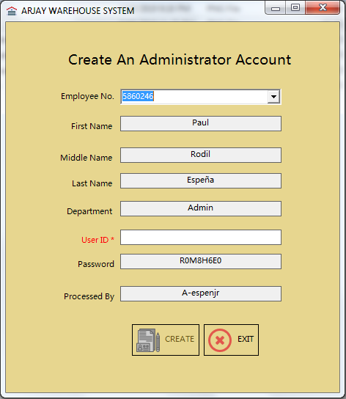

Note: The Administrator is required to enter the user ID depending on the company’s naming convention or user id format.

Snapshot once User ID has been entered:

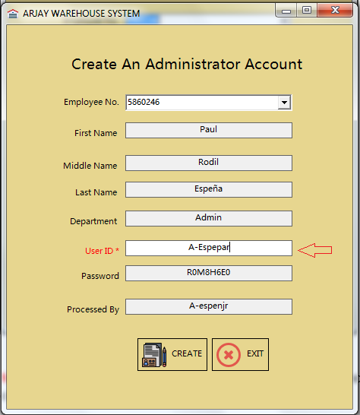

Reminder: The create button will not go to active state if there’s an empty field.

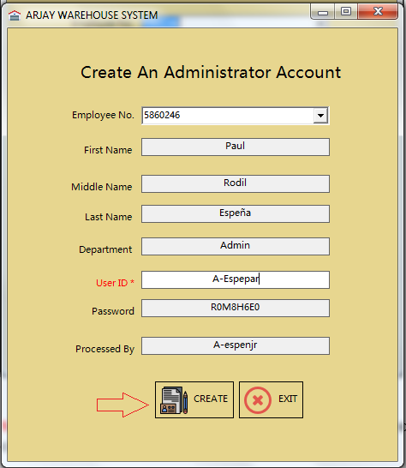

After clicking the create button a message prompt will appear notifying the Administrator that new access or account has been created.

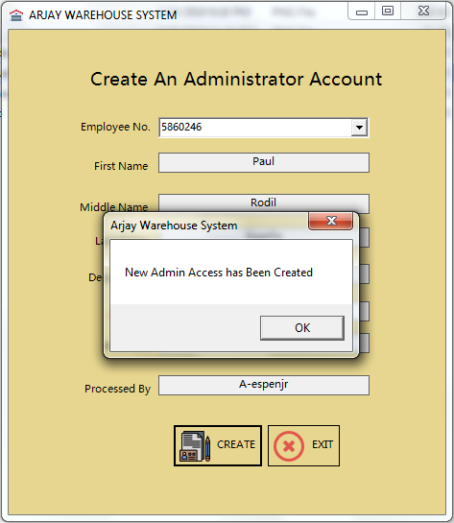

Click ok to go back to the form.

If the Administrator decided to click the Exit button then a confirmation message will appear.

By clicking the Yes button, system will redirect the Administrator back to Admin Panel. If No then the Administrator will stay on the same page or form.

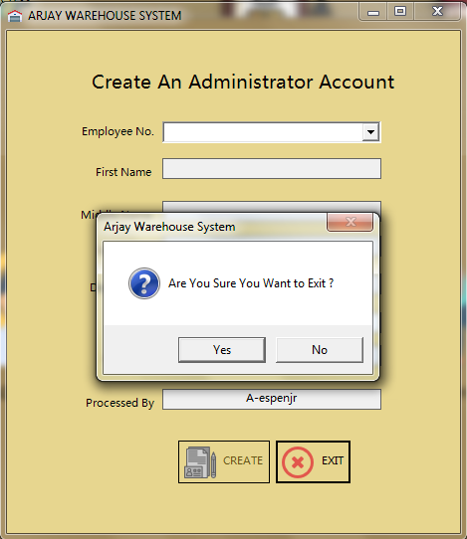

Note: This whole procedure is applicable for all three access roles. Admin, Dispatch and receiving. Form design may be different from each other but process and data gathering are all the same.

* 1. Terminate Access

Use this to terminate current access to this system “Arjay Warehouse System”. This procedure is applicable for all three access roles Admin, Dispatch and Receiving.

Reminder: To terminate an access please ensure that the employee is present to the users’ access list (Please see Create access procedure and View users’ information procedure).

The administrator needs to click the button or icon as described below.

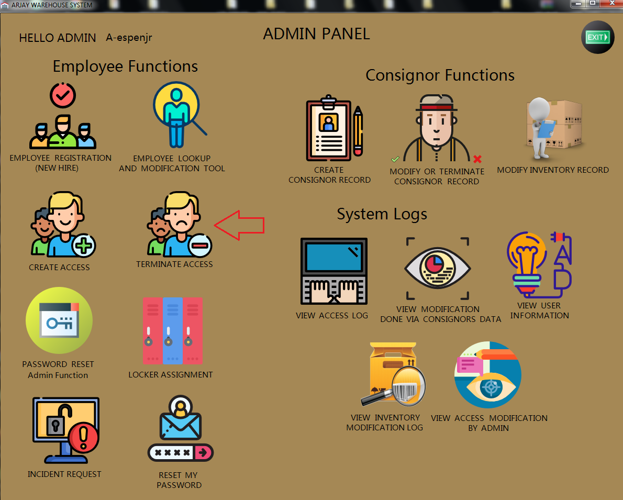

After clicking the Terminate Access button from the Admin Dashboard the Delete Access Panel will show up.

Snapshot of Delete Access Form:

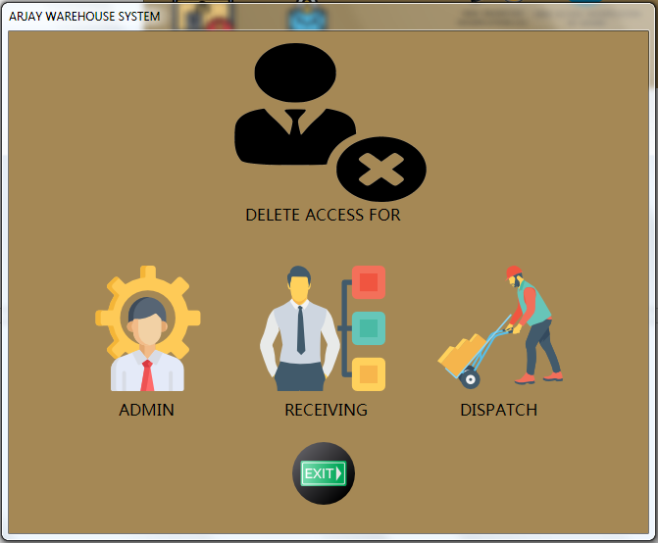

Administrator is required to choose the type of access that needs to be created.

Note: The procedure for all three roles are all the same as far as data and information are all concern.

After choosing or clicking the type of access needed, the Delete / Terminate access form will appear.

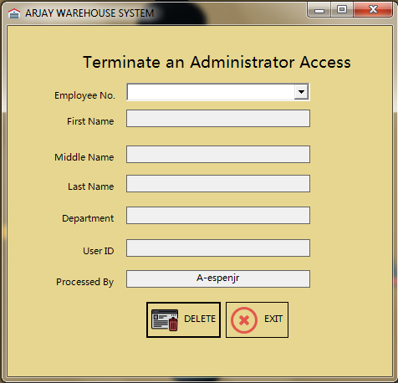

Administrator needs to click the drop-down arrow next to Employee No.

Note: To view all available Employee no. and access, the administrator have two options. Administrator can use either the Employee Lookup Tool or View Users Information.

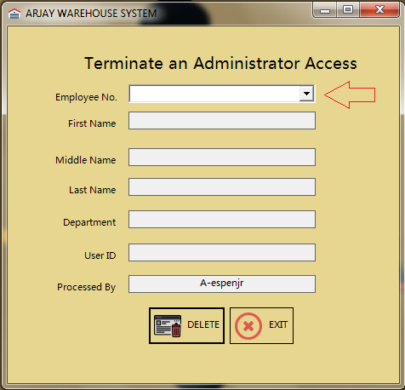

Snapshot after choosing the employees Employee No.

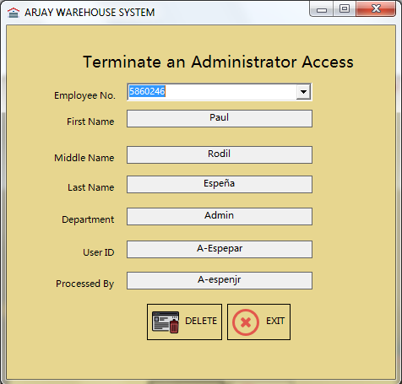

Reminder: The Delete button will not go to active state if no Employee no. is selected.

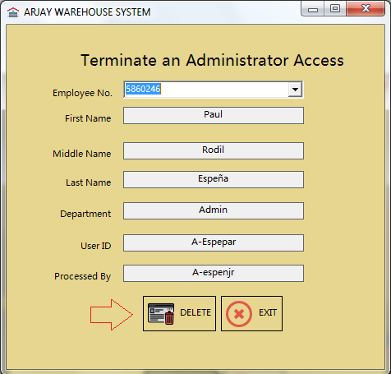

After clicking the Delete button a message prompt will appear notifying the Administrator that an Access has been terminated.

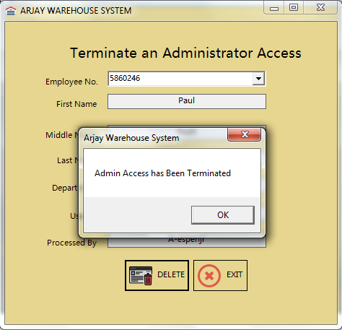

Click ok to go back to the form.

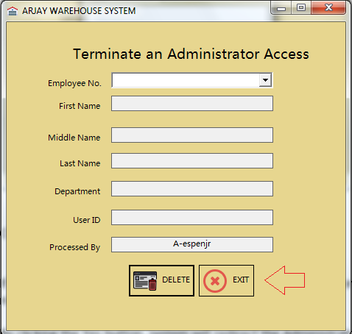

If the Administrator decided to click the Exit button then a confirmation message will appear.

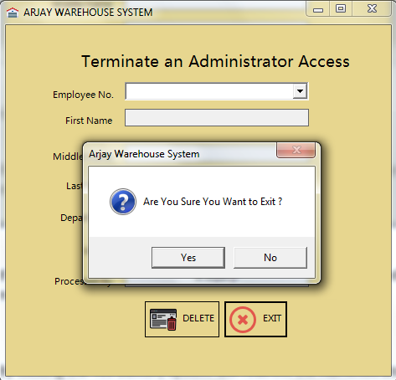

By clicking the Yes button, system will redirect the Administrator back to Admin Panel. If No then the Administrator will stay on the same page or form.

Note: This whole procedure is applicable for all three access roles. Admin, Dispatch and receiving. Form design may be different from each other but process and data gathering are all the same.

Reminder: Please take note that terminating an access is different from terminating an employee profile or record. Using this process Administrator will be able to terminate an access but if employee records needs to be deleted (i.e. Termination) please see the procedure for Employee Lookup and Modification tool.

* 1. Password Reset – Admin Function

Use this to reset an employee’s password. This procedure is applicable for all three access roles Admin, Dispatch and Receiving.

The administrator needs to click the button or icon as described below.

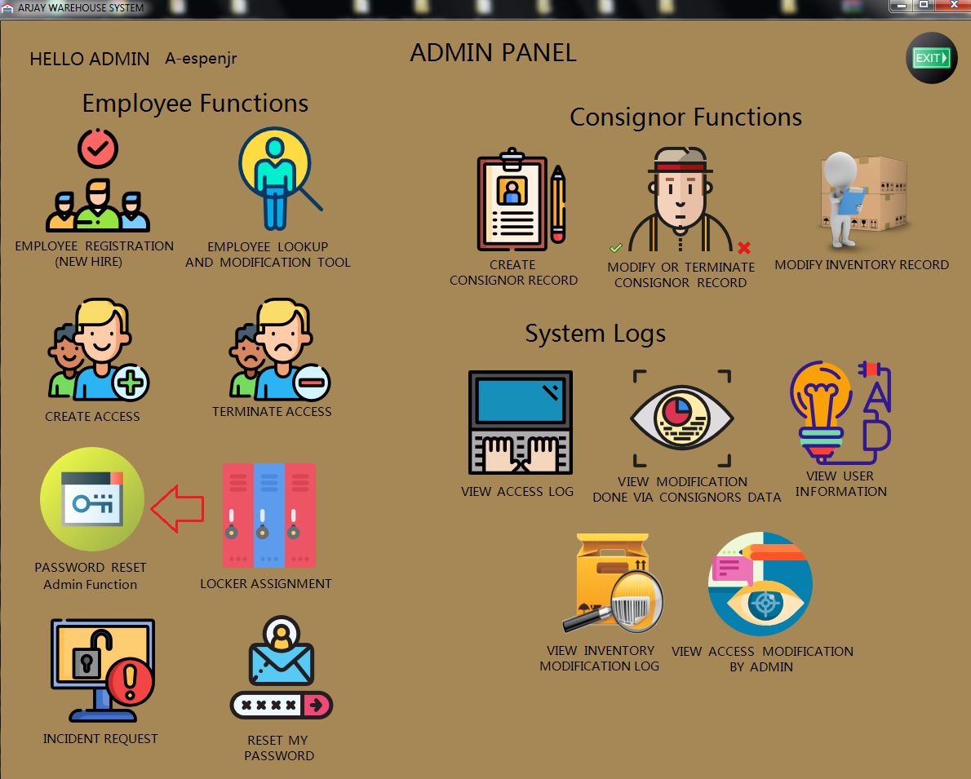

After clicking the Password Reset (Admin Function) button from the Admin Dashboard the Password Reset Panel will show up.

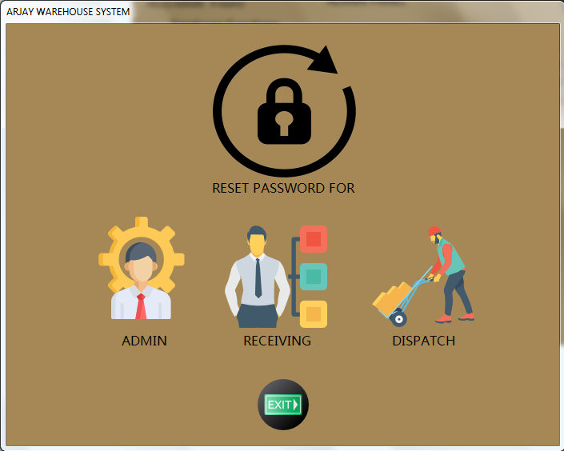

Administrator is required to choose the type of access that needs to reset.

Note: The procedure for all three roles are all the same as far as data and information are all concern.

After choosing or clicking the type of access needed, the password reset form will appear.

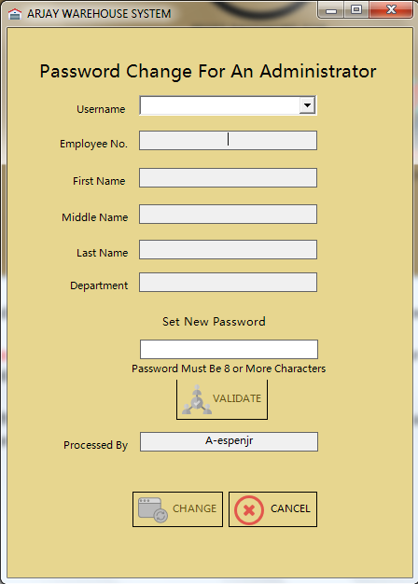

Administrator needs to click the drop-down arrow next to Username.

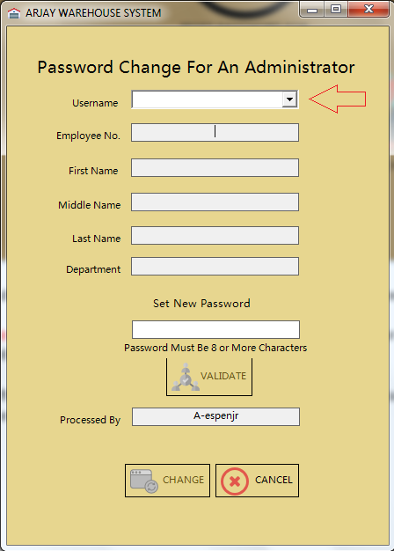

Snapshot after choosing the employees Username.

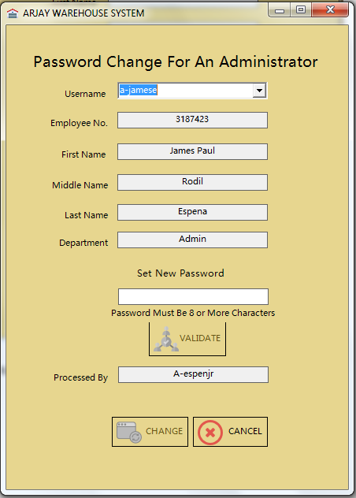

Note: The Administrator is required to enter a password manually depending on company’s password strength requirements. And also the validate button will remain inactive if the “Set New Password” field is empty.

Snapshot after entering a new password and once the validate button becomes active.

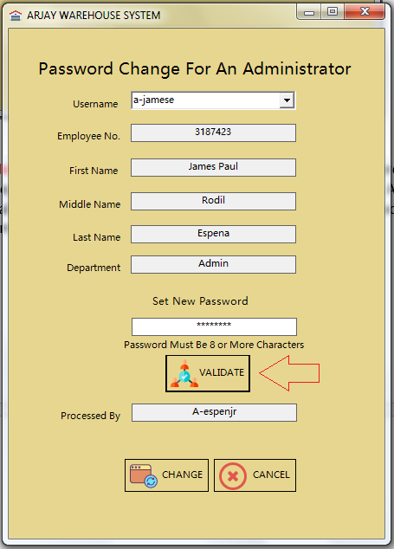

Snapshot once the system validated the new password.

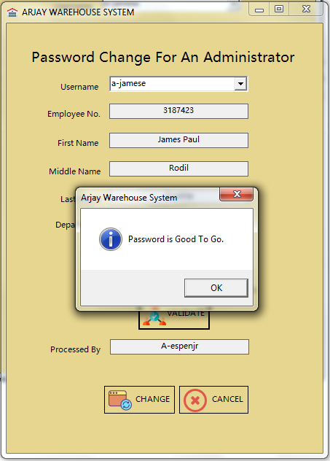

Note: Once the system recognize that the new set of password has conflict with other users an error message will show up and system will not allow it to go through.

Snapshot once the system validated a conflicted password.

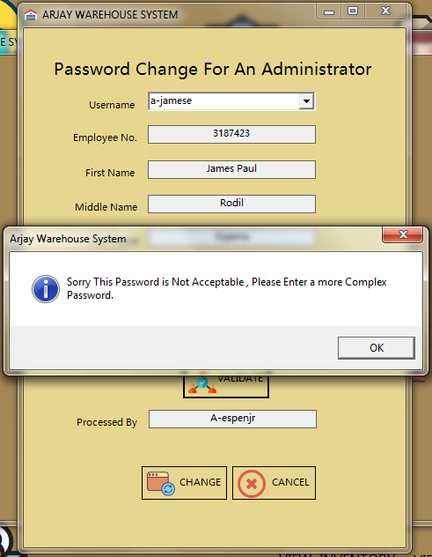

Once the password is good or met the said system requirements the Administrator can now click the Change button.

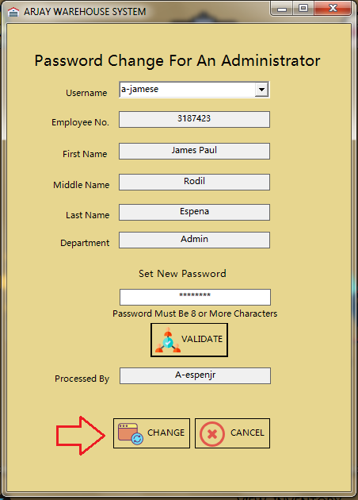

After clicking the Change button a message prompt will appear notifying the Administrator that Password has been change.

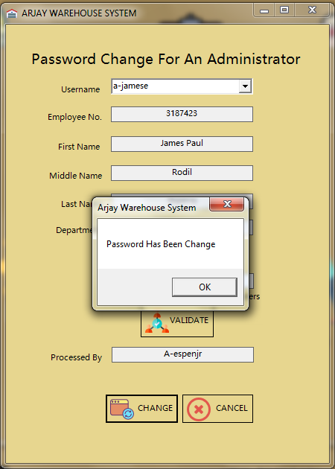

Click ok to go back to the form.

If the Administrator decided to click the Cancel button then a confirmation message will appear.

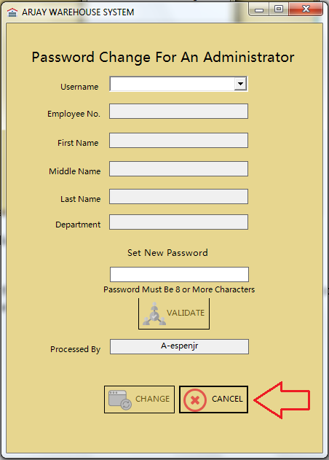

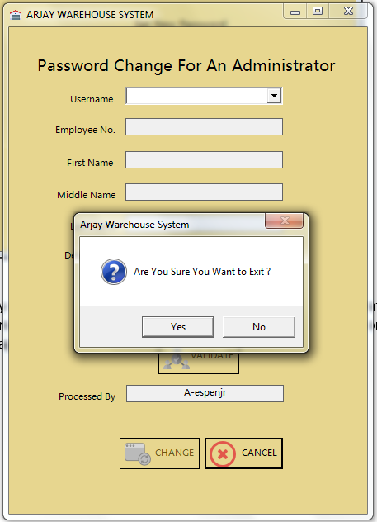

By clicking the Yes button, system will redirect the Administrator back to Admin Panel. If No then the Administrator will stay on the same page or form.

Note: This whole procedure is applicable for all three access roles. Admin, Dispatch and receiving. Form design may be different from each other but process and data gathering are all the same.

* 1. Locker Assignment

Use this issue a locker for production employees.

Reminder: To issue a Locker please ensure that the employee is present to the employee’s database or record (Please see Employee Registration process).

The administrator needs to click the button or icon as described below.

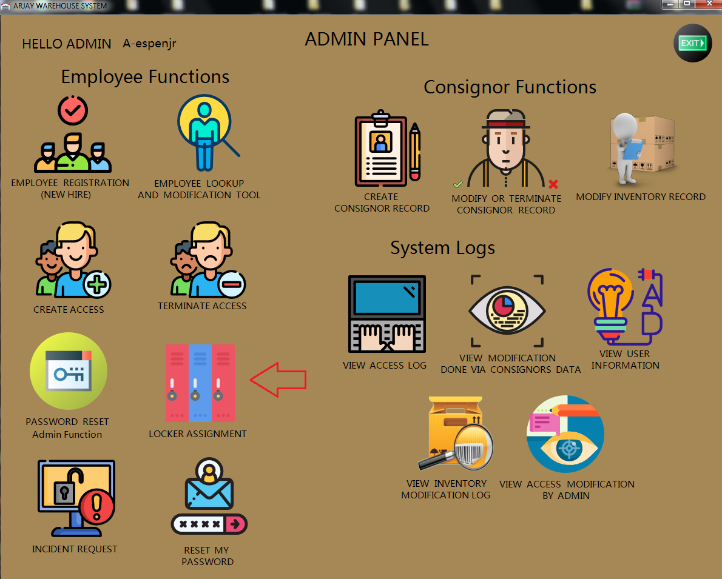

After clicking the Locker Assignment button from the Admin Dashboard the Locker Issuance Form will show up.

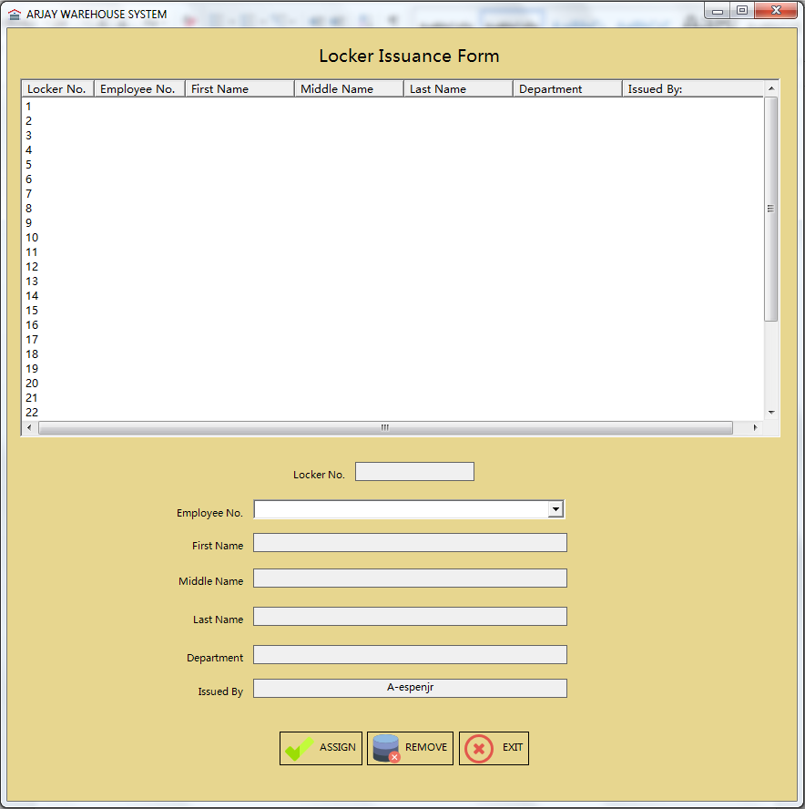

Note: Locker Issuance Form is being divided into three sections.

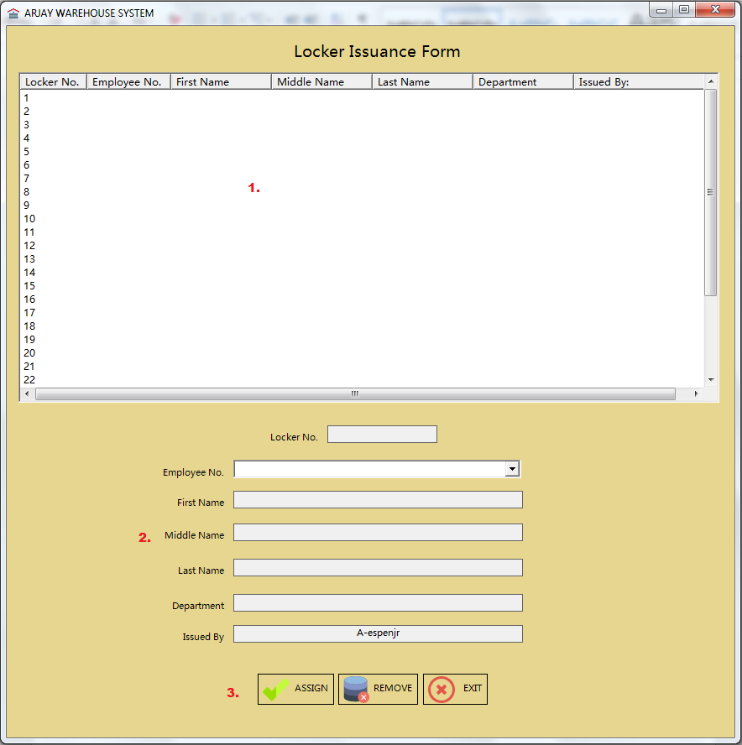

Here are the sections and its purpose:

1. List view area – This area contains the locker information as well as the current user listed.
2. Employee Information – This will display the information of the employee.
3. Function buttons – Buttons required to execute request inside Locker Issuance form.

To assign a locker the Administrator needs to choose a locker no. first step is by simply clicking the number listed in the List view area and after doing that the no. will be displayed at the bottom or at the Employee Information Section as described on the image below.

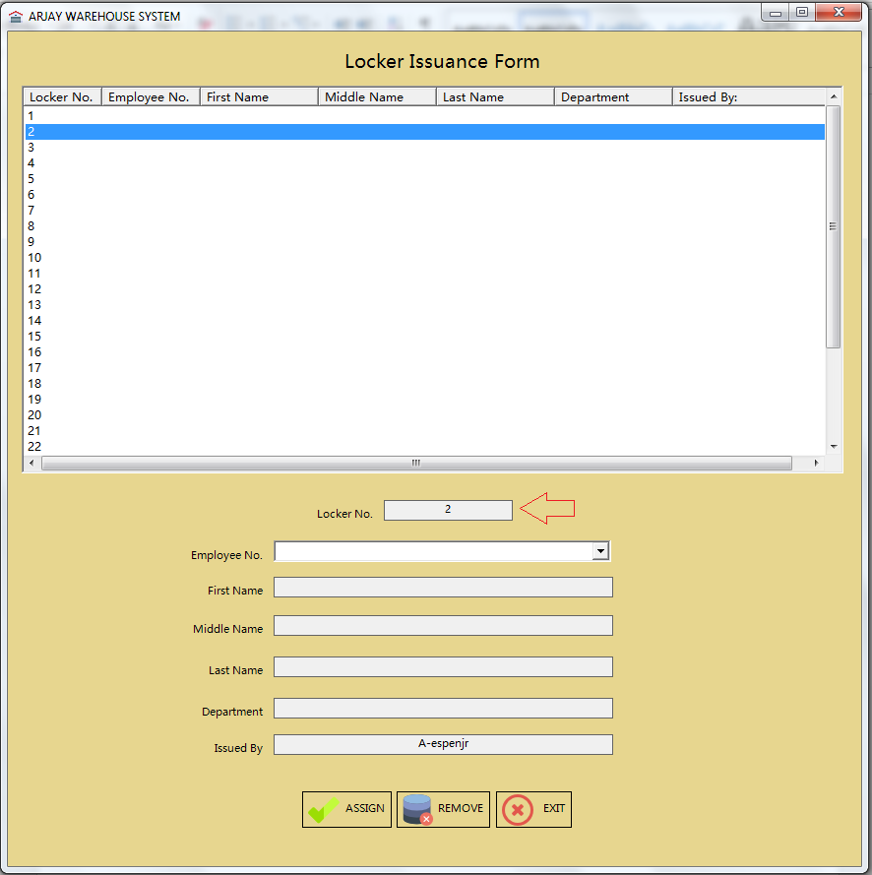

After choosing a Locker no. the administrator is required to click the dropdown next to Employee no. and choose the appropriate employee no.

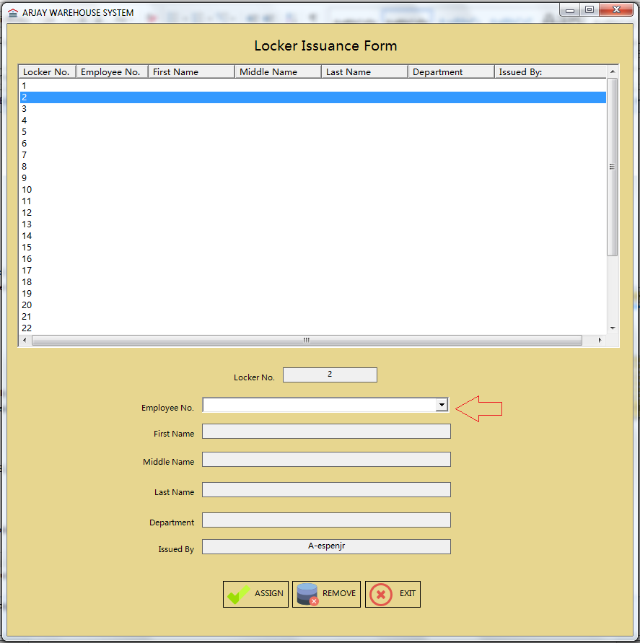

Note: Only employees that are present in the employee database will be recognize by the system.

After choosing an Employee no. other fields will be generated automatically.

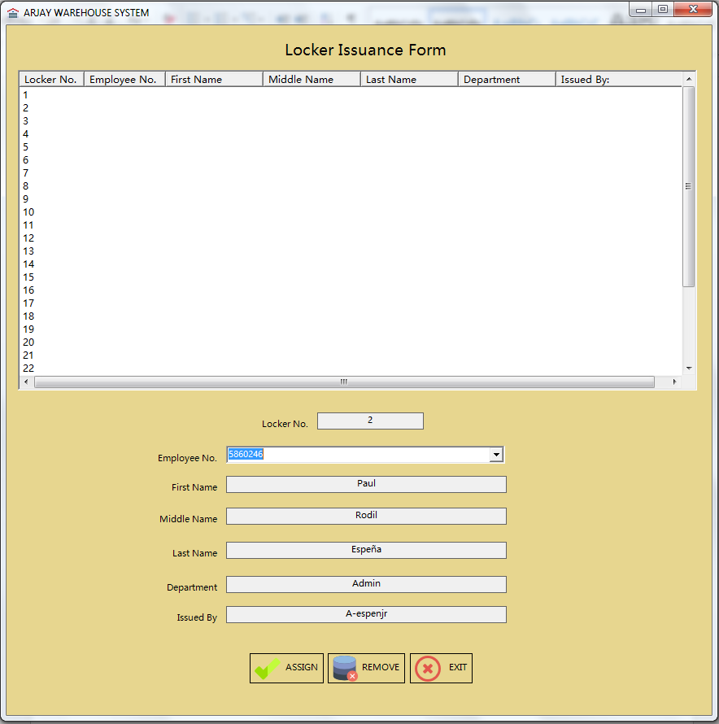

Click the Assign button to assign the locker accordingly to the employee.

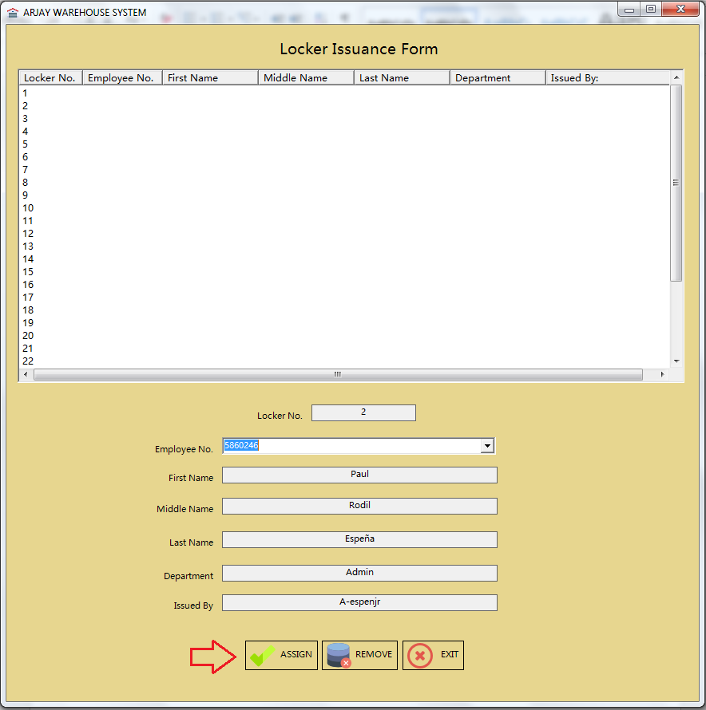

After clicking the Assign button a confirmation message will appear notifying the administrator that the “Locker has been assigned”.

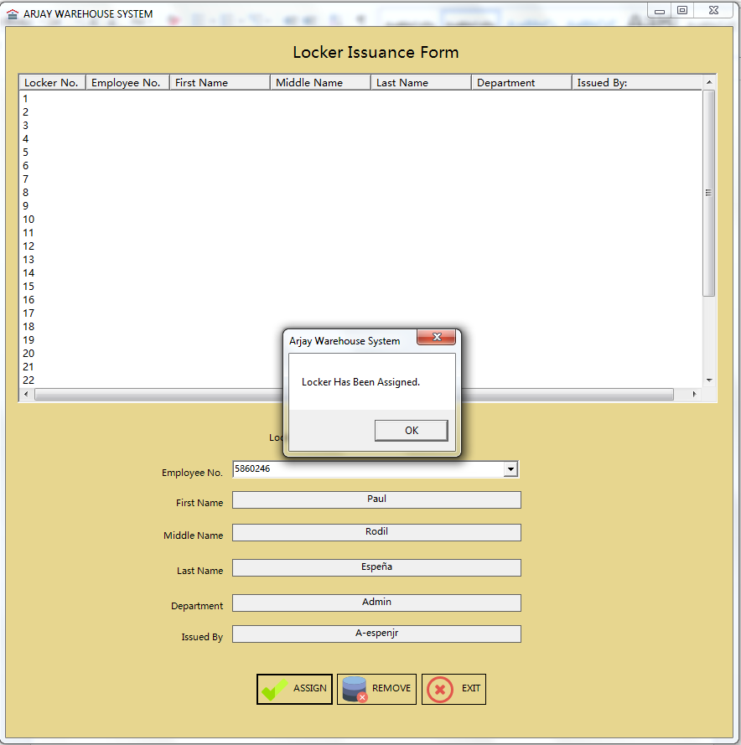

Click OK in order for the employees’ data to reflect inside the List View area.

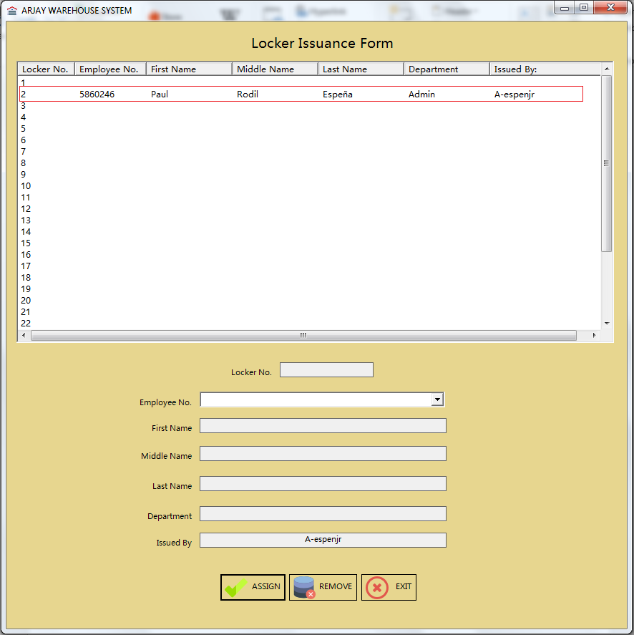

Note: To remove the locker assignment the procedure required is almost the same with assign or issuance process.

To remove Locker Assignment, the Administrator needs to click the employees’ details inside the List View area.

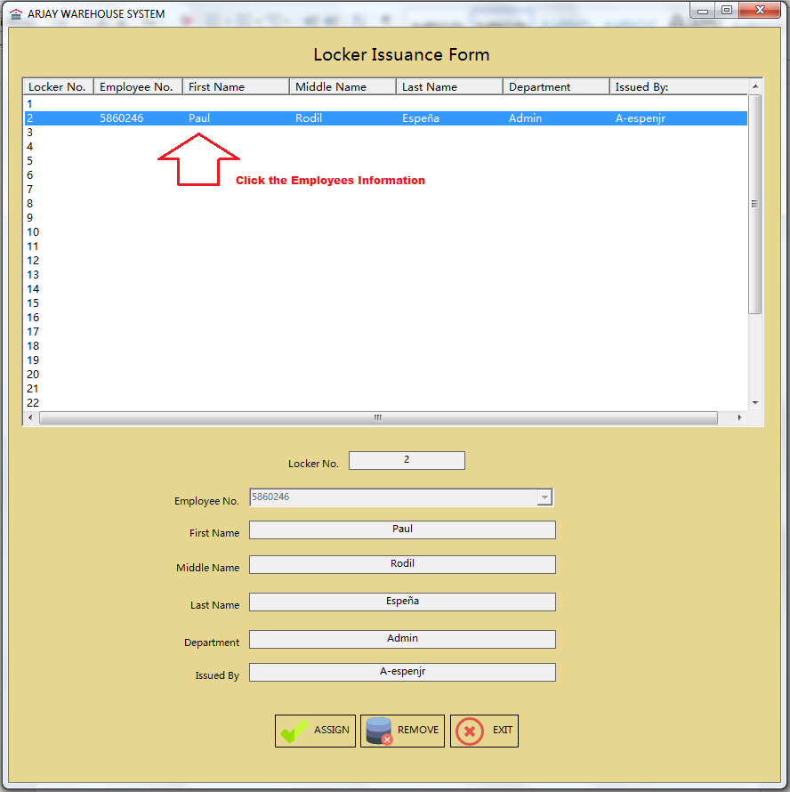

Once the administrator click the employees information the data below will be filled automatically.

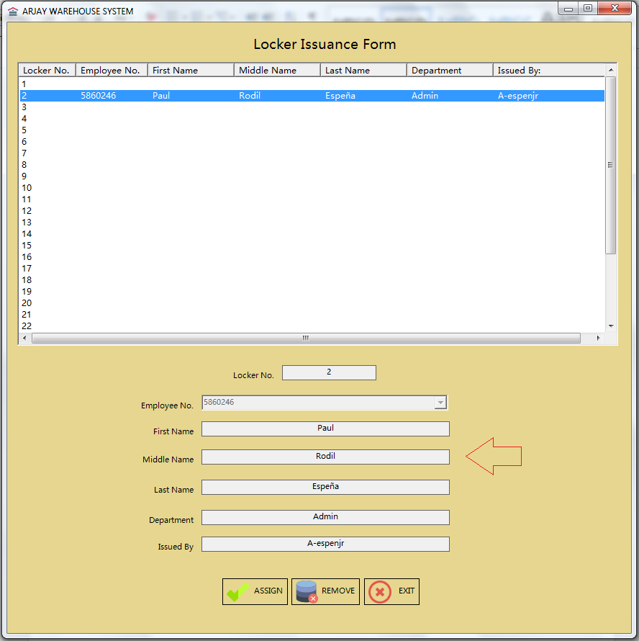

Click the Remove button to un-assign the employees’ data from the locker no.

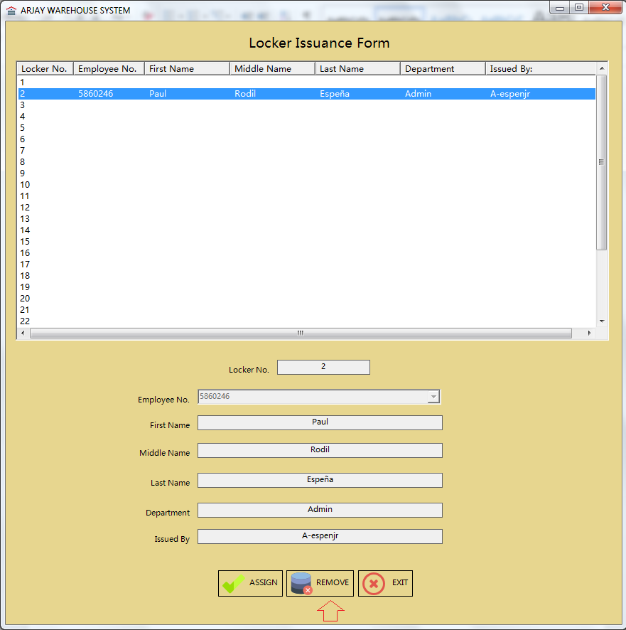

Confirmation message will appear notifying the administrator that “Locker has been unassigned”.

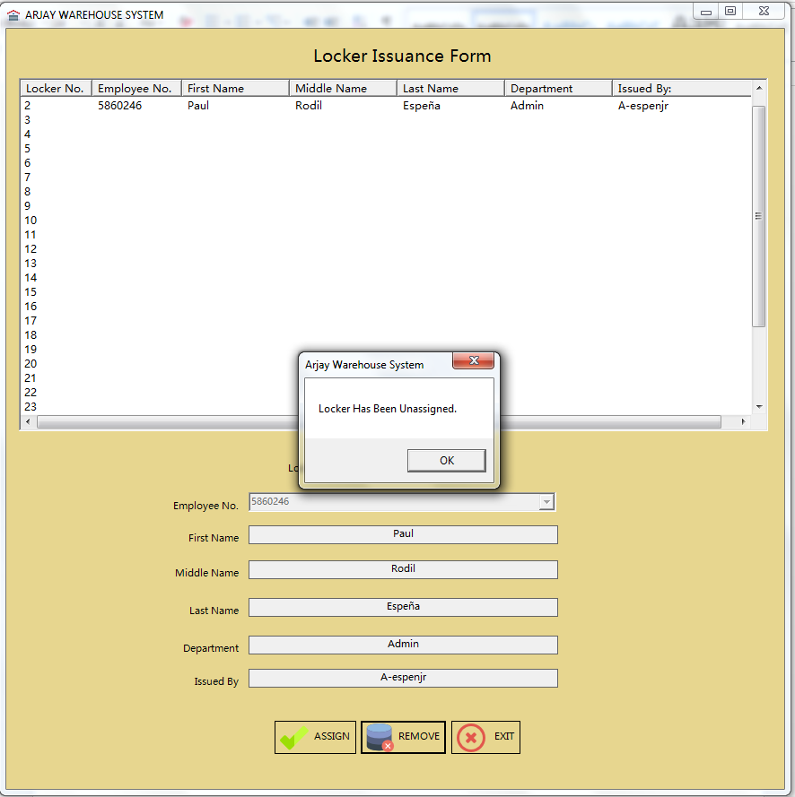

Hit ok to refresh the List View area and to finalize the process.

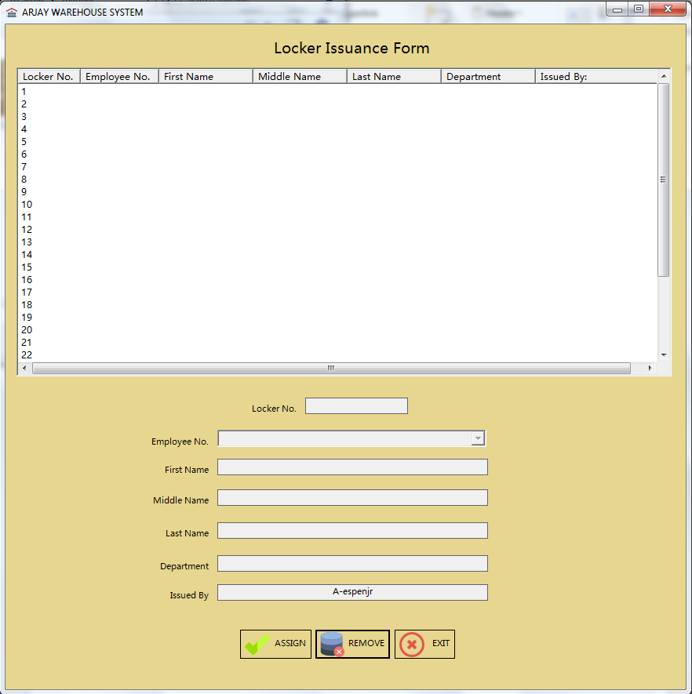

If the Administrator decided to click the Exit button then a confirmation message will appear.

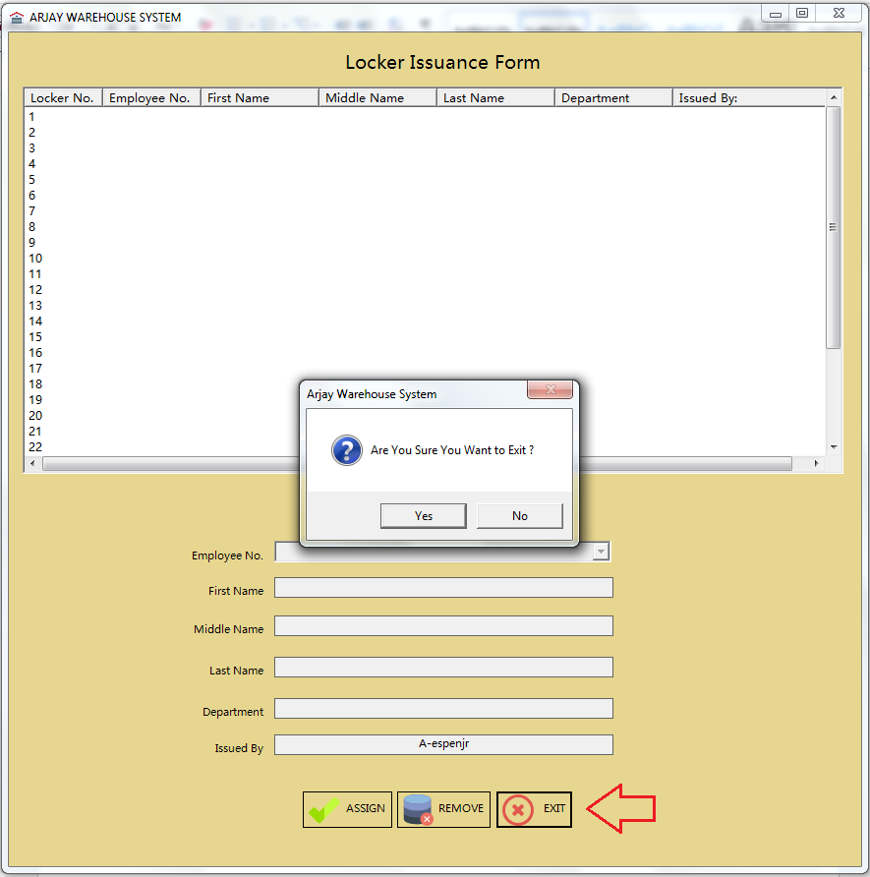

By clicking the Yes button, system will redirect the Administrator back to Admin Panel. If No then the Administrator will stay on the same page or form.

* 1. Incident Request

Use this issue view correction and incident request submitted by a receiving and dispatch personnel.

The administrator needs to click the button or icon as described below.

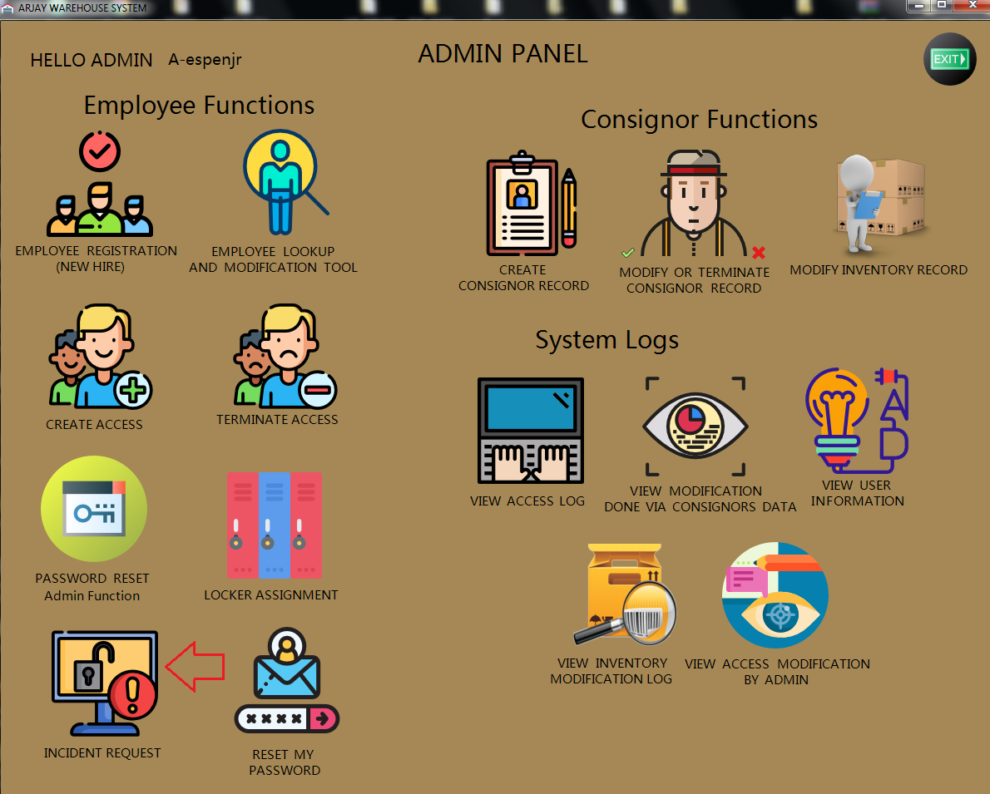

After clicking the Incident Request button from the Admin Dashboard the Admin Correction Form will show up.

Snapshot of Admin Correction Form:

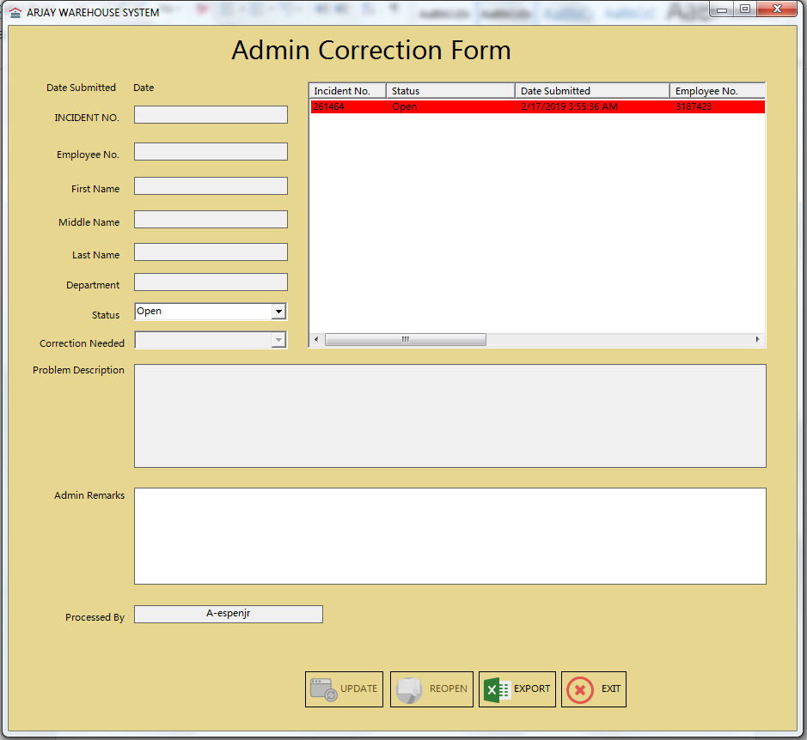

Note: Admin Correction Form is being divided into three sections.

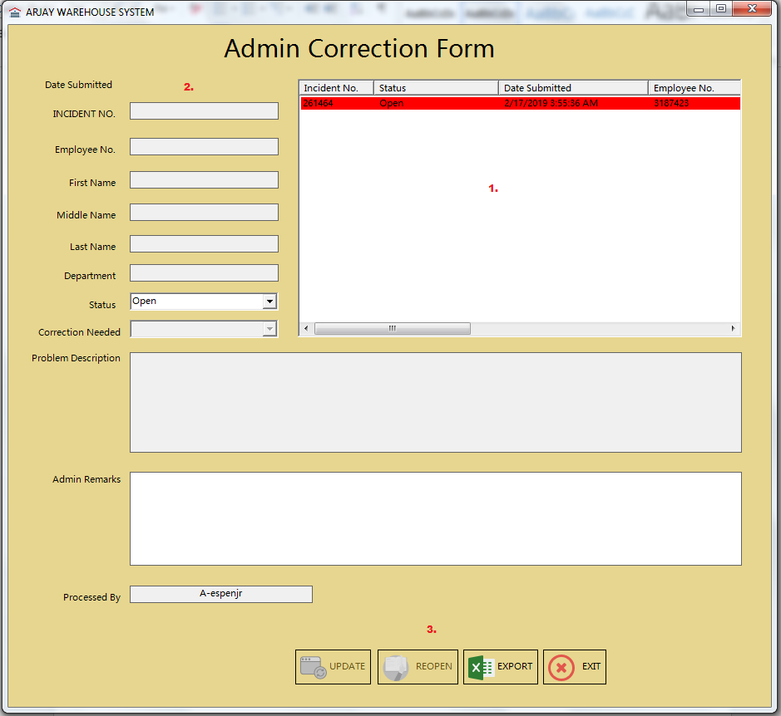

Here are the sections and its purpose:

1. List view area – This area contains the locker information as well as the current user listed.
2. Employee Information – This will display the information of the employee as well as the Incident or Request no.
3. Function buttons – Buttons required to execute request inside Locker Issuance form.

Reminder: All open request will be highlighted in red.

The first step to resolve an open request is by clicking the Incident number listed in the List view area.

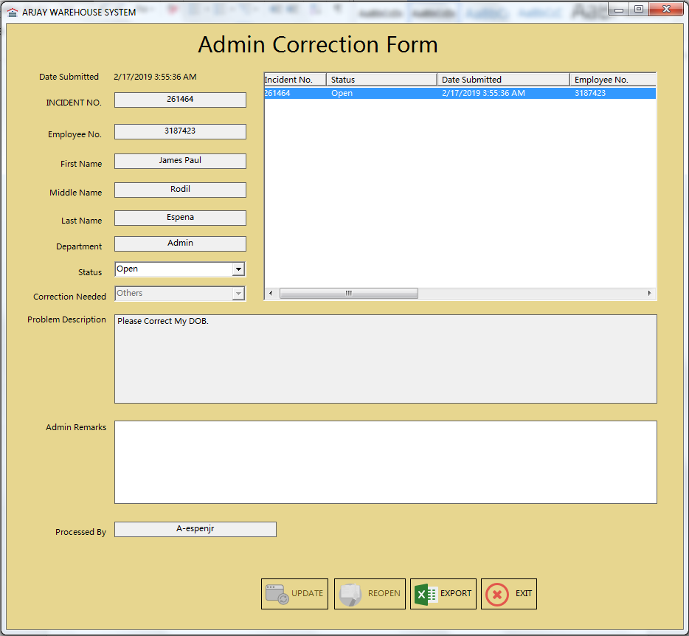

Note: Please ensure to fix the request first prior in resolving any Incident or request.

Once the request has been executed, the next step is to set the request into a close or resolved status. The administrator needs to change the status from open to a resolved state (as described on the screenshot below).

Just click the dropdown and choose “Resolved”.

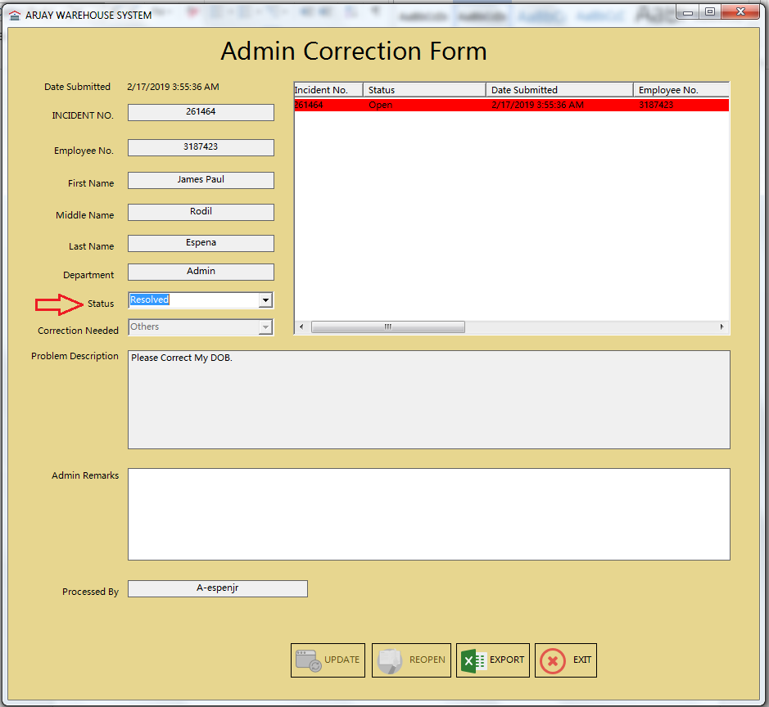

Note: The Update button will remain inactive up until the administrator place a note onto the request or Incident record.

Once the documentation has been set via Admin Remarks administrator needs to click the Update button.

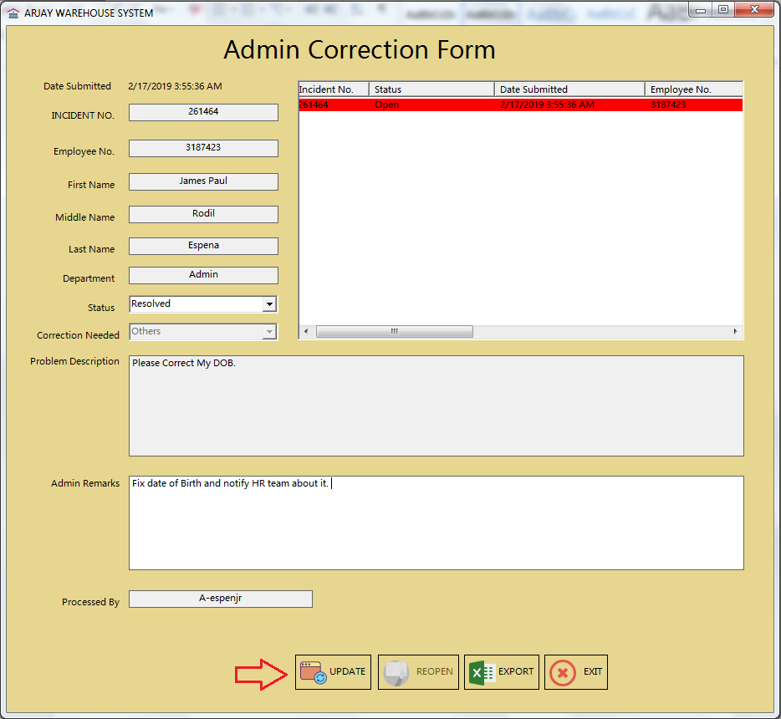

After clicking the Update button a confirmation message will appear stating that the “Correction request has been resolved”.

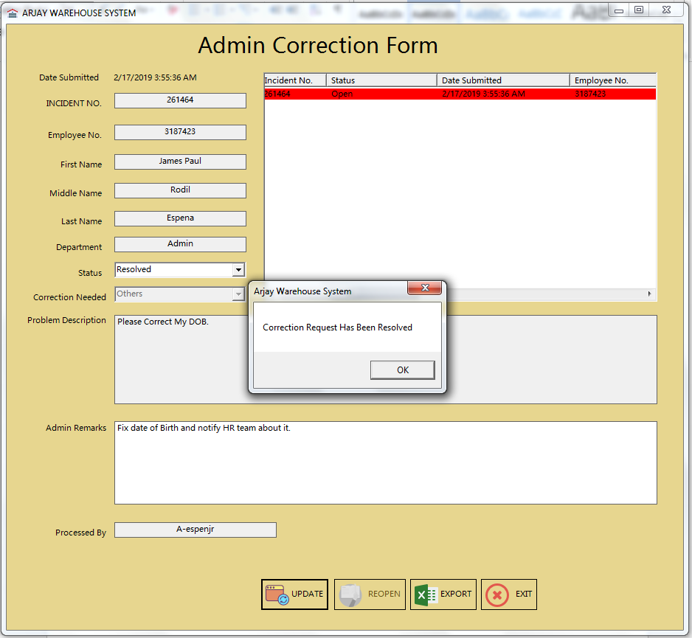

Click OK to finalize the process for the system to update the List View data as well.

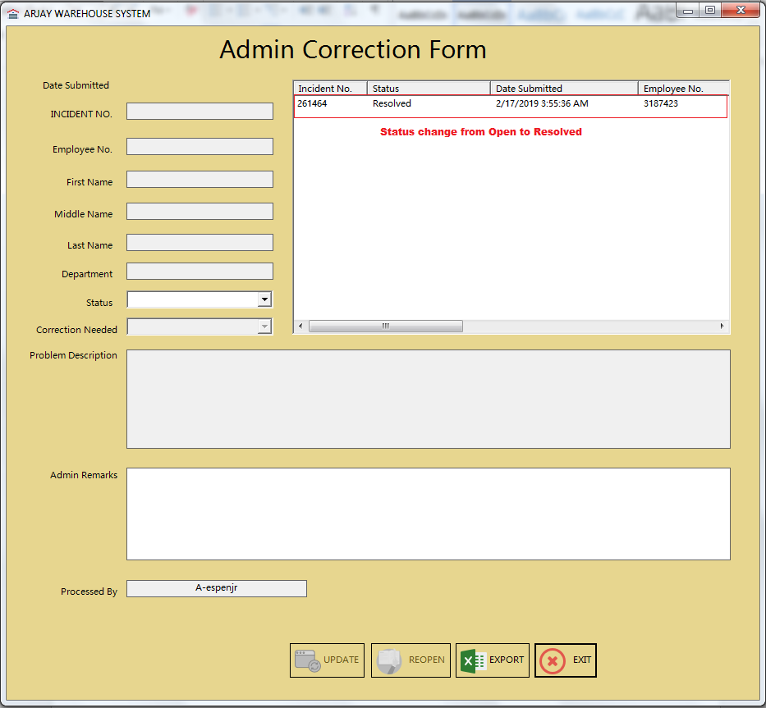

Note: The procedure for re-opening an Incident / Correction request is slightly different.